Full Name | N S S Kiran
Batch | MS FSD DEC 2021 Cohort 1
Project Name | Kiran Sporty Shoes
Project Submission Date | 18-05-2022

Source Code
ShoesWebApplication.java
package com.webshoe;

import org.springframework.boot.SpringApplication;
import org.springframework.boot.autoconfigure.SpringBootApplication;

@SpringBootApplication
public class ShoesWebApplication {

public static void main(String[] args) {
SpringApplication.run(ShoesWebApplication.class, args);
}
}

SportyShoesSecurityConfiguration.java
package com.webshoe.configuration;

import org.springframework.context.annotation.Configuration;
import org.springframework.http.HttpMethod;
import org.springframework.security.config.annotation.authentication.builders.AuthenticationManagerBuilder;
import org.springframework.security.config.annotation.web.builders.HttpSecurity;
import org.springframework.security.config.annotation.web.configuration.WebSecurityConfigurerAdapter;

@Configuration
public class SprotyShoesSecurityConfiguration extends WebSecurityConfigurerAdapter {

@Override
protected void configure(HttpSecurity http) throws Exception {
http.authorizeRequests()
.antMatchers(HttpMethod.GET, "/admin/**").hasRole("ADMIN")
.antMatchers("/users/**")
.permitAll().and().httpBasic();
http.csrf().disable();
}

@Override
protected void configure(AuthenticationManagerBuilder auth) throws Exception {
auth.inMemoryAuthentication().withUser("admin").password("{noop}admin").roles("ADMIN");
}

}
AdminController.java
package com.webshoe.controller;

import java.text.ParseException;
import java.util.List;
import java.util.Optional;

import org.springframework.beans.factory.annotation.Autowired;
import org.springframework.http.HttpStatus;
import org.springframework.http.ResponseEntity;
import org.springframework.web.bind.annotation.DeleteMapping;
import org.springframework.web.bind.annotation.GetMapping;
import org.springframework.web.bind.annotation.PathVariable;
import org.springframework.web.bind.annotation.PostMapping;
import org.springframework.web.bind.annotation.RequestBody;
import org.springframework.web.bind.annotation.RequestMapping;
import org.springframework.web.bind.annotation.RequestParam;
import org.springframework.web.bind.annotation.RestController;

import com.webshoe.entity.Product;
import com.webshoe.entity.PurchaseReport;
import com.webshoe.entity.User;
import com.webshoe.service.ProductService;
import com.webshoe.service.PurchaseReportService;
import com.webshoe.service.UserService;

@RestController
@RequestMapping("/admin")
public class AdminController {

@Autowired
ProductService productService;

@Autowired
UserService userService;

@Autowired
private PurchaseReportService purchaseReportService;

@GetMapping("/products")
public ResponseEntity<List<Product>> getAllProducts() {
List<Product> allProducts = productService.getAllProducts();
if (allProducts.isEmpty()) {
return new ResponseEntity<>(HttpStatus.NO_CONTENT);
}
ResponseEntity<List<Product>> responseEntity = new ResponseEntity<List<Product>>(allProducts, HttpStatus.OK);
return responseEntity;
}

@GetMapping("/products/categorize/{category}")
public ResponseEntity<List<Product>> getAllProductsBasedOnCategory(@PathVariable("category") String category) {
System.out.println("Category to look for -> " + category);
List<Product> allProductsBasedOnCategory = productService.getAllProductBasedOnCatogary(category);
if (allProductsBasedOnCategory.isEmpty()) {
return new ResponseEntity<>(HttpStatus.NO_CONTENT);
}
ResponseEntity<List<Product>> responseEntity = new ResponseEntity<List<Product>>(allProductsBasedOnCategory,
HttpStatus.OK);
return responseEntity;
}

@PostMapping("/products")
public ResponseEntity<Product> addProduct(@RequestBody Product product) {
Product temp = productService.addProduct(product);
if (temp == null) {
return new ResponseEntity<Product>(HttpStatus.BAD_REQUEST);
}
return new ResponseEntity<Product>(temp, HttpStatus.OK);

}

@GetMapping("/products/{productId}")
public ResponseEntity<Product> getProductById(@PathVariable("productId") int id) {
Optional<Product> product = productService.getProductById(id);
if (!product.isPresent()) {
return new ResponseEntity<Product>(HttpStatus.NO_CONTENT);
}

return new ResponseEntity<Product>(product.get(), HttpStatus.OK);
}

@DeleteMapping("/products/{productId}")
public ResponseEntity<HttpStatus> deleteById(@PathVariable("productId") int id) {
productService.deleteProductById(id);
return new ResponseEntity<>(HttpStatus.OK);
}

@GetMapping("/users")
public ResponseEntity<List<User>> getAllSignedUpUsers() {
List<User> allSignedUpUsers = userService.allSignedUpUsers();
if (allSignedUpUsers.isEmpty()) {
return new ResponseEntity<List<User>>(HttpStatus.NO_CONTENT);
}
return new ResponseEntity<List<User>>(allSignedUpUsers, HttpStatus.OK);

}

@GetMapping("/users/{userName}")
public ResponseEntity<User> getSignedUpUser(@PathVariable("userName") String userName) {
Optional<User> signedUpUser = userService.getSignedUpUserByName(userName);
if (!signedUpUser.isPresent()) {
return new ResponseEntity<User>(HttpStatus.NOT_FOUND);
}
return new ResponseEntity<User>(signedUpUser.get(), HttpStatus.OK);
}

@GetMapping("/purchasereport")
public ResponseEntity<List<PurchaseReport>> getPurchaseReport() {
List<PurchaseReport> purchaseReport = purchaseReportService.getAllPurchaseReport();
if (purchaseReport.isEmpty()) {
return new ResponseEntity<List<PurchaseReport>>(HttpStatus.NO_CONTENT);
}
return new ResponseEntity<List<PurchaseReport>>(purchaseReport, HttpStatus.OK);

}

@GetMapping("/purchasereport/category/{category}")
public ResponseEntity<List<PurchaseReport>> getPurchaseReportBasedOnCategory(@PathVariable("category") String category) {
List<PurchaseReport> purchaseReportBasedOnCategory = purchaseReportService.getPurchaseReportBasedOnCategory(category);
if (purchaseReportBasedOnCategory.isEmpty()) {
return new ResponseEntity<List<PurchaseReport>>(HttpStatus.NO_CONTENT);
}
return new ResponseEntity<List<PurchaseReport>>(purchaseReportBasedOnCategory, HttpStatus.OK);

}

@GetMapping("/purchasereport/date/{date}")
public ResponseEntity<List<PurchaseReport>> getPurchaseReportBasedOnDate(@PathVariable("date") String date) throws ParseException {
System.out.println("Date from url is : " + date);
List<PurchaseReport> purchaseReportBasedOnCategory = purchaseReportService.getPurchaseReportBasedOnDate(date);
if (purchaseReportBasedOnCategory.isEmpty()) {
return new ResponseEntity<List<PurchaseReport>>(HttpStatus.NO_CONTENT);
}
return new ResponseEntity<List<PurchaseReport>>(purchaseReportBasedOnCategory, HttpStatus.OK);

}
}
UserController.java
package com.webshoe.controller;

import java.security.SecureRandom;
import java.util.Date;
import java.util.Optional;

import org.springframework.beans.factory.annotation.Autowired;
import org.springframework.security.crypto.bcrypt.BCryptPasswordEncoder;
import org.springframework.transaction.annotation.Transactional;
import org.springframework.web.bind.annotation.PathVariable;
import org.springframework.web.bind.annotation.PostMapping;
import org.springframework.web.bind.annotation.RequestBody;
import org.springframework.web.bind.annotation.RequestMapping;
import org.springframework.web.bind.annotation.ResponseBody;
import org.springframework.web.bind.annotation.RestController;

import com.webshoe.entity.Product;
import com.webshoe.entity.User;
import com.webshoe.service.ProductService;
import com.webshoe.service.PurchaseReportService;
import com.webshoe.service.UserService;

@RestController
@RequestMapping("/users")
public class UserController {

@Autowired
private UserService userService;

@Autowired
private ProductService productService;

@Autowired
private PurchaseReportService purchaseReportService;

@PostMapping("/signup")
public @ResponseBody String register(@RequestBody(required = false) User user) {
if (user == null) {
return "Enter Valid User Details - User details should not be Null";
}else if(user.getUserName() == null || user.getUserPassword()== null || user.getUserEmail() == null) {
return "Enter Valid User Details - All the fields(Name, Password, Email) are mandatory";
}
int strength = 10;
BCryptPasswordEncoder bCryptPasswordEncoder = new BCryptPasswordEncoder(strength, new SecureRandom());
String encodedPassword = bCryptPasswordEncoder.encode(user.getUserPassword());
user.setUserPassword(encodedPassword);
user.setUserName(user.getUserName().toLowerCase());
userService.signUp(user);
return "Signed Up Successfully!";
}

@PostMapping("/{userId}/buy/{productName}")
@Transactional
public @ResponseBody String buyProductByName(@PathVariable(name = "userId") int userID,
@PathVariable("productName") String productName) {
Optional<Product> product = productService.getProductByName(productName);
if (product.isPresent()) {
Optional<User> user = userService.getSignedUpUserById(userID);
if (user.isPresent()) {
User user2 = user.get();
user2.addProduct(product.get());
Product product2 = product.get();
product2.addUser(user.get());
userService.saveUserWithProduct(user2);
productService.addProduct(product2);
purchaseReportService.savePurchaseReport(product2.getProductName(), product2.getCategory(),
product2.getProductPrice(), user2.getUserName(), user2.getUserEmail(), new Date());
return "You have successfully bought : " + product.get().getProductName();
} else {
return "User Not Found! to buy the Product";
}
}
return "Product Not Found!";
}
}
Product.java
package com.webshoe.entity;

import java.util.ArrayList;
import java.util.List;

import javax.persistence.CascadeType;
import javax.persistence.Entity;
import javax.persistence.FetchType;
import javax.persistence.GeneratedValue;
import javax.persistence.GenerationType;
import javax.persistence.Id;
import javax.persistence.ManyToMany;
import javax.persistence.Table;

import com.fasterxml.jackson.annotation.JsonIgnoreProperties;

@Entity
@Table(name = "product")
//Added below line to not get Infinite loop when retriving user and product details
@JsonIgnoreProperties({ "hibernateLazyInitializer", "handler", "users" })
public class Product {

@Id
@GeneratedValue(strategy = GenerationType.IDENTITY)
private int productId;

private String productName;

private int productPrice;

private String category;

@ManyToMany(fetch = FetchType.LAZY, cascade = { CascadeType.PERSIST, CascadeType.MERGE }, mappedBy = "products")
private List<User> users = new ArrayList<User>();

public void addUser(User user) {
this.users.add(user);
}

@Override
public String toString() {

return "Custom ToString -> Product";
}

public int getProductId() {
return productId;
}

public void setProductId(int productId) {
this.productId = productId;
}

public String getProductName() {
return productName;
}

public void setProductName(String productName) {
this.productName = productName;
}

public int getProductPrice() {
return productPrice;
}

public void setProductPrice(int productPrice) {
this.productPrice = productPrice;
}

public String getCategory() {
return category;
}

public void setCategory(String category) {
this.category = category;
}

public List<User> getUsers() {
return users;
}

public void setUsers(List<User> users) {
this.users = users;
}

public Product(int productId, String productName, int productPrice, String category, List<User> users) {
super();
this.productId = productId;
this.productName = productName;
this.productPrice = productPrice;
this.category = category;
this.users = users;
}

public Product() {
super();
}

public Product(String productName, int productPrice, String category, List<User> users) {
super();
this.productName = productName;
this.productPrice = productPrice;
this.category = category;
this.users = users;
}

}
PurchaseReport.java
package com.webshoe.entity;
import java.util.Date;

import javax.persistence.Entity;
import javax.persistence.GeneratedValue;
import javax.persistence.GenerationType;
import javax.persistence.Id;
import javax.persistence.Temporal;
import javax.persistence.TemporalType;

@Entity
public class PurchaseReport {

@Id
@GeneratedValue(strategy = GenerationType.IDENTITY)
private int id;

private String categoryOfProduct;

private String productName;

private int priceOfTheProduct;

private String userWhoBoughtTheProduct;

private String userEmailBoughtTheProduct;

@Temporal(TemporalType.DATE)
private Date dateOfProductPurchase;

public PurchaseReport(String productName, String categoryOfProduct, int priceOfTheProduct, String userWhoBoughtTheProduct, String userEmailBoughtTheProduct, Date dateOfProductPurchase) {
this.productName = productName;
this.categoryOfProduct = categoryOfProduct;
this.userWhoBoughtTheProduct = userWhoBoughtTheProduct;
this.dateOfProductPurchase = dateOfProductPurchase;
this.userEmailBoughtTheProduct = userEmailBoughtTheProduct;
this.priceOfTheProduct = priceOfTheProduct;
}

public int getId() {
return id;
}

public void setId(int id) {
this.id = id;
}

public String getCategoryOfProduct() {
return categoryOfProduct;
}

public void setCategoryOfProduct(String categoryOfProduct) {
this.categoryOfProduct = categoryOfProduct;
}

public String getProductName() {
return productName;
}

public void setProductName(String productName) {
this.productName = productName;
}

public int getPriceOfTheProduct() {
return priceOfTheProduct;
}

public void setPriceOfTheProduct(int priceOfTheProduct) {
this.priceOfTheProduct = priceOfTheProduct;
}

public String getUserWhoBoughtTheProduct() {
return userWhoBoughtTheProduct;
}

public void setUserWhoBoughtTheProduct(String userWhoBoughtTheProduct) {
this.userWhoBoughtTheProduct = userWhoBoughtTheProduct;
}

public String getUserEmailBoughtTheProduct() {
return userEmailBoughtTheProduct;
}

public void setUserEmailBoughtTheProduct(String userEmailBoughtTheProduct) {
this.userEmailBoughtTheProduct = userEmailBoughtTheProduct;
}

public Date getDateOfProductPurchase() {
return dateOfProductPurchase;
}

public void setDateOfProductPurchase(Date dateOfProductPurchase) {
this.dateOfProductPurchase = dateOfProductPurchase;
}

public PurchaseReport(int id, String categoryOfProduct, String productName, int priceOfTheProduct,
String userWhoBoughtTheProduct, String userEmailBoughtTheProduct, Date dateOfProductPurchase) {
super();
this.id = id;
this.categoryOfProduct = categoryOfProduct;
this.productName = productName;
this.priceOfTheProduct = priceOfTheProduct;
this.userWhoBoughtTheProduct = userWhoBoughtTheProduct;
this.userEmailBoughtTheProduct = userEmailBoughtTheProduct;
this.dateOfProductPurchase = dateOfProductPurchase;
}

public PurchaseReport() {
super();
}

@Override
public String toString() {
return "PurchaseReport [id=" + id + ", categoryOfProduct=" + categoryOfProduct + ", productName=" + productName
+ ", priceOfTheProduct=" + priceOfTheProduct + ", userWhoBoughtTheProduct=" + userWhoBoughtTheProduct
+ ", userEmailBoughtTheProduct=" + userEmailBoughtTheProduct + ", dateOfProductPurchase="
+ dateOfProductPurchase + "]";
}

}
User.java
package com.webshoe.entity;

import java.util.ArrayList;
import java.util.List;

import javax.persistence.CascadeType;
import javax.persistence.Column;
import javax.persistence.Entity;
import javax.persistence.FetchType;
import javax.persistence.GeneratedValue;
import javax.persistence.GenerationType;
import javax.persistence.Id;
import javax.persistence.JoinColumn;
import javax.persistence.JoinTable;
import javax.persistence.ManyToMany;
import javax.persistence.Table;

@Entity
@Table(name = "user")
public class User {

@Id
@GeneratedValue(strategy = GenerationType.IDENTITY)
private int userId;

@Column(name = "name")
private String userName;

@Column(name = "email")
private String userEmail;

@Column(name = "password")
private String userPassword;

@ManyToMany(fetch = FetchType.LAZY, cascade = { CascadeType.PERSIST, CascadeType.MERGE })
@JoinTable(name = "USER_PRODUCT", joinColumns = @JoinColumn(name = "USER_ID"), inverseJoinColumns = @JoinColumn(name = "PRODUCT_ID"))
private List<Product> products = new ArrayList<Product>();

public User(String userName, String userEmail) {
this.userEmail = userEmail;
this.userName = userName;
}

public void addProduct(Product product) {
this.products.add(product);
}

@Override
public String toString() {
return "Custom ToString -> User [userId=" + userId + ", userName=" + userName + ", userEmail=" + userEmail + ", userPassword="
+ userPassword + ", products=" + products + "]";
}

public int getUserId() {
return userId;
}

public void setUserId(int userId) {
this.userId = userId;
}

public String getUserName() {
return userName;
}

public void setUserName(String userName) {
this.userName = userName;
}

public String getUserEmail() {
return userEmail;
}

public void setUserEmail(String userEmail) {
this.userEmail = userEmail;
}

public String getUserPassword() {
return userPassword;
}

public void setUserPassword(String userPassword) {
this.userPassword = userPassword;
}

public List<Product> getProducts() {
return products;
}

public void setProducts(List<Product> products) {
this.products = products;
}

public User(int userId, String userName, String userEmail, String userPassword, List<Product> products) {
super();
this.userId = userId;
this.userName = userName;
this.userEmail = userEmail;
this.userPassword = userPassword;
this.products = products;
}

public User(String userName, String userEmail, String userPassword, List<Product> products) {
super();
this.userName = userName;
this.userEmail = userEmail;
this.userPassword = userPassword;
this.products = products;
}

public User() {
super();
}

}
ProductRepository.java
package com.webshoe.repository;

import java.util.List;
import java.util.Optional;

import org.springframework.data.jpa.repository.JpaRepository;
import org.springframework.data.jpa.repository.Query;
import org.springframework.data.repository.query.Param;
import org.springframework.stereotype.Repository;

import com.webshoe.entity.Product;

@Repository
public interface ProductRepository extends JpaRepository<Product, Integer>{

@Query(value = "select p from Product p where p.category=:category")
List<Product> findAllByCategory(@Param("category") String category);

@Query(value = "select p from Product p where p.productName=:productName")
Optional<Product> findByName(@Param("productName") String name);
}
PurchaseReportRepository.java
package com.webshoe.repository;

import java.util.Date;
import java.util.List;

import org.springframework.data.jpa.repository.JpaRepository;
import org.springframework.data.jpa.repository.Query;
import org.springframework.data.repository.query.Param;
import org.springframework.stereotype.Repository;

import com.webshoe.entity.PurchaseReport;

@Repository
public interface PurchaseReportRepository extends JpaRepository<PurchaseReport, Integer> {

@Query("select pr from PurchaseReport pr where pr.categoryOfProduct=:category")
List<PurchaseReport> findAllByCategory(@Param("category") String category);

@Query("select pr from PurchaseReport pr where pr.dateOfProductPurchase=:date")
List<PurchaseReport> findAllByDate(@Param("date") Date date);

}
UserRepository.java
package com.webshoe.repository;

import java.util.Optional;

import org.springframework.data.jpa.repository.JpaRepository;
import org.springframework.data.jpa.repository.Query;
import org.springframework.data.repository.query.Param;
import org.springframework.stereotype.Repository;

import com.webshoe.entity.User;

@Repository
public interface UserRepository extends JpaRepository<User, Integer> {

@Query(value = "select u from User u where u.userName=:userName")
Optional<User> findUserByName(@Param("userName")String userName);

}
ProductService.java
package com.webshoe.service;

import java.util.List;
import java.util.Optional;

import org.springframework.beans.factory.annotation.Autowired;
import org.springframework.stereotype.Service;

import com.webshoe.entity.Product;
import com.webshoe.repository.ProductRepository;

@Service
public class ProductService {

@Autowired
ProductRepository productRepository;

public Product addProduct(Product product) {
return productRepository.save(product);
}

public Product addProductWithUser(Product product) {
return productRepository.save(product);
}

public Optional<Product> getProductById(int id) {
Optional<Product> proOptional = productRepository.findById(id);
return proOptional;
}

public Optional<Product> getProductByName(String name) {
Optional<Product> proOptional = productRepository.findByName(name);
return proOptional;
}

public List<Product> getAllProducts() {
return productRepository.findAll();
}

public List<Product> getAllProductBasedOnCatogary(String category) {
return productRepository.findAllByCategory(category);
}

public void deleteProductById(int prdId) {
productRepository.deleteById(prdId);
}

}
PurchaseReportService.java
package com.webshoe.service;

import java.text.ParseException;
import java.text.SimpleDateFormat;
import java.util.Date;
import java.util.List;

import org.springframework.beans.factory.annotation.Autowired;
import org.springframework.stereotype.Service;

import com.webshoe.entity.PurchaseReport;
import com.webshoe.repository.PurchaseReportRepository;

@Service
public class PurchaseReportService {

@Autowired
private PurchaseReportRepository purchaseReportRepository;

public void savePurchaseReport(String productName, String category, int productPrice, String userName, String userEmail, Date date) {
PurchaseReport purchaseReport = new PurchaseReport(productName, category, productPrice, userName, userEmail, date);
purchaseReportRepository.save(purchaseReport);
}

public List<PurchaseReport> getAllPurchaseReport() {
List<PurchaseReport> purchaseReports = purchaseReportRepository.findAll();
return purchaseReports;
}

public List<PurchaseReport> getPurchaseReportBasedOnCategory(String category) {
List<PurchaseReport> purchaseReports = purchaseReportRepository.findAllByCategory(category);
return purchaseReports;
}

public List<PurchaseReport> getPurchaseReportBasedOnDate(String date) throws ParseException {
List<PurchaseReport> purchaseReports = purchaseReportRepository.findAllByDate(new SimpleDateFormat("yyyy-MM-dd").parse(date));
return purchaseReports;
}

}
UserService.java
package com.webshoe.service;

import java.util.List;
import java.util.Optional;

import org.springframework.beans.factory.annotation.Autowired;
import org.springframework.stereotype.Service;

import com.webshoe.entity.User;
import com.webshoe.repository.UserRepository;

@Service
public class UserService {

@Autowired
UserRepository userRepository;

public User signUp(User user) {
return userRepository.save(user);
}

public User saveUserWithProduct(User user) {
return userRepository.save(user);
}

public List<User> allSignedUpUsers() {
return userRepository.findAll();
}
public Optional<User> getSignedUpUserByName(String name) {
Optional<User> user = userRepository.findUserByName(name);
return user;
}
public Optional<User> getSignedUpUserById(int id) {
Optional<User> user = userRepository.findById(id);
return user;
}
}
Application.properties
spring.datasource.url=jdbc:mysql://localhost:3306/sportyshoes
spring.datasource.username=root
spring.datasource.password=Kiran@256

spring.datasource.driverClassName=com.mysql.jdbc.Driver
spring.jpa.properties.hibernate.dialect = org.hibernate.dialect.MySQL5Dialect

spring.mvc.pathmatch.matching-strategy=ant-path-matcher
spring.jpa.generate-ddl=true
spring.jpa.hibernate.ddl-auto= update
spring.jpa.show-sql=true
spring.jpa.properties.hibernate.format_sql=true
logging.level.org.hibernate.type=trace

server.port = 8081
Pom.xml
<?xml version="1.0" encoding="UTF-8"?>
<project xmlns="http://maven.apache.org/POM/4.0.0" xmlns:xsi="http://www.w3.org/2001/XMLSchema-instance"
xsi:schemaLocation="http://maven.apache.org/POM/4.0.0 https://maven.apache.org/xsd/maven-4.0.0.xsd">
<modelVersion>4.0.0</modelVersion>
<parent>
<groupId>org.springframework.boot</groupId>
<artifactId>spring-boot-starter-parent</artifactId>
<version>2.6.4</version>
<relativePath /> <!-- lookup parent from repository -->
</parent>
<groupId>com.webshoe</groupId>
<artifactId>shoes-web</artifactId>
<version>0.0.1-SNAPSHOT</version>
<name>shoes-web</name>
<description>Online web Service</description>
<properties>
<java.version>1.8</java.version>
</properties>
<dependencies>
<dependency>
<groupId>org.springframework.boot</groupId>
<artifactId>spring-boot-starter-data-jpa</artifactId>
</dependency>
<!-- https://mvnrepository.com/artifact/com.fasterxml.jackson.dataformat/jackson-dataformat-xml -->
<dependency>
<groupId>com.fasterxml.jackson.dataformat</groupId>
<artifactId>jackson-dataformat-xml</artifactId>
</dependency>
<dependency>
<groupId>org.springframework.boot</groupId>
<artifactId>spring-boot-starter-security</artifactId>
</dependency>
<dependency>
<groupId>org.springframework.boot</groupId>
<artifactId>spring-boot-starter-web</artifactId>
</dependency>

<dependency>
<groupId>org.springframework.boot</groupId>
<artifactId>spring-boot-devtools</artifactId>
<scope>runtime</scope>
<optional>true</optional>
</dependency>
<dependency>
<groupId>mysql</groupId>
<artifactId>mysql-connector-java</artifactId>
<scope>runtime</scope>
</dependency>
<dependency>
<groupId>org.springframework.boot</groupId>
<artifactId>spring-boot-starter-test</artifactId>
<scope>test</scope>
</dependency>
<dependency>
<groupId>org.springframework.security</groupId>
<artifactId>spring-security-test</artifactId>
<scope>test</scope>
</dependency>
<!-- <dependency> <groupId>io.springfox</groupId> <artifactId>springfox-boot-starter</artifactId>
<version>3.0.0</version> </dependency> <dependency> <groupId>io.springfox</groupId>
<artifactId>springfox-swagger-ui</artifactId> <version>3.0.0</version> </dependency> -->
<dependency>
<groupId>io.springfox</groupId>
<artifactId>springfox-swagger2</artifactId>
<version>2.9.2</version>
</dependency>

<dependency>
<groupId>io.springfox</groupId>
<artifactId>springfox-swagger-ui</artifactId>
<version>2.9.2</version>
</dependency>

</dependencies>

<build>
<plugins>
<plugin>
<groupId>org.springframework.boot</groupId>
<artifactId>spring-boot-maven-plugin</artifactId>
</plugin>
</plugins>
</build>

</project>

Screen Shots
Products
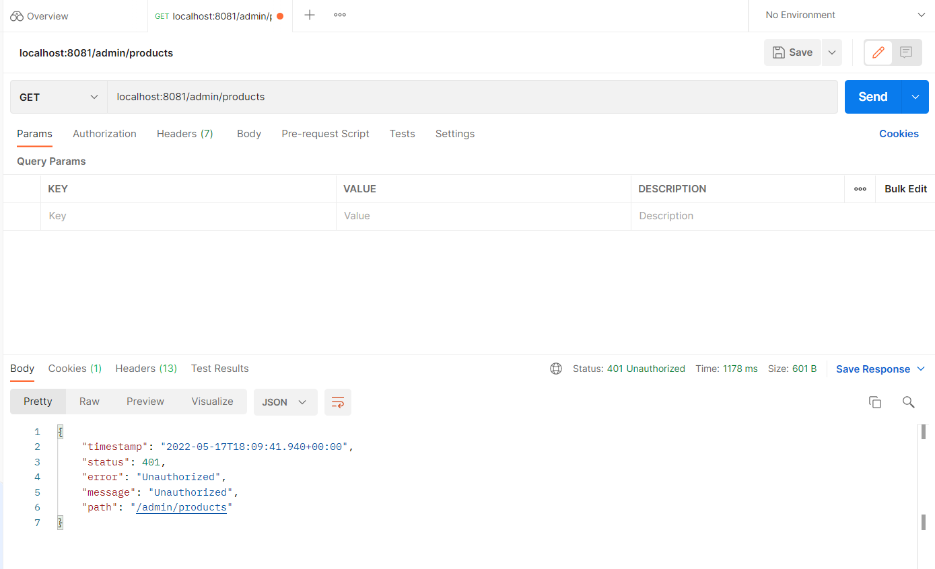
Get Method
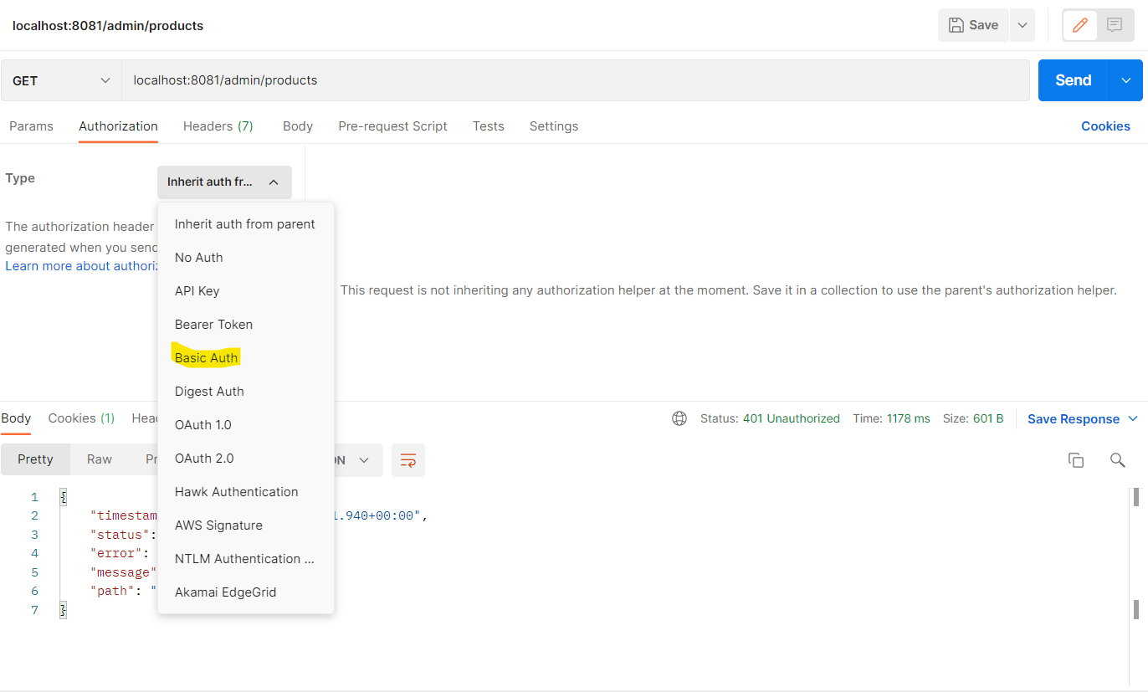
Admin Page
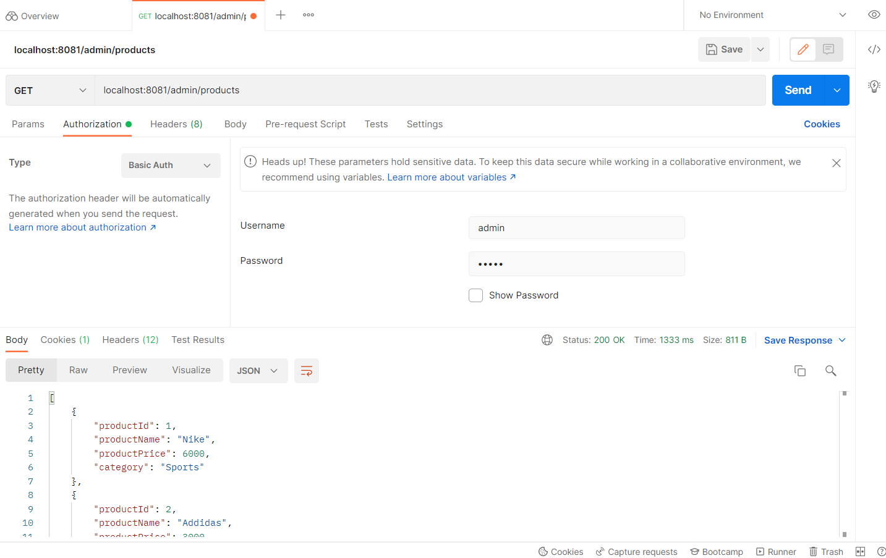
Products
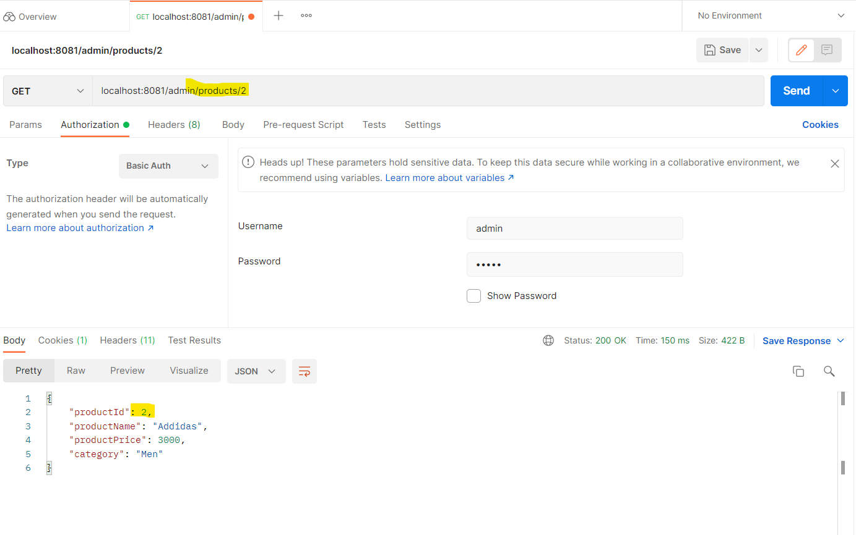

User
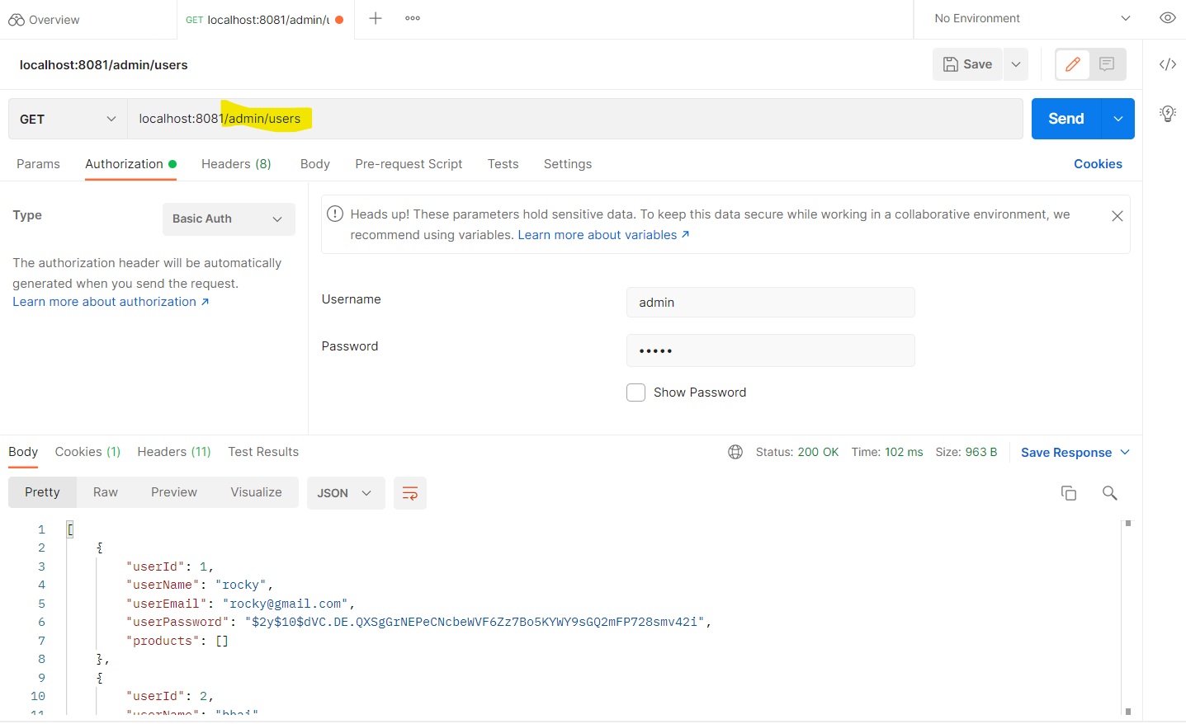
Purchase Report
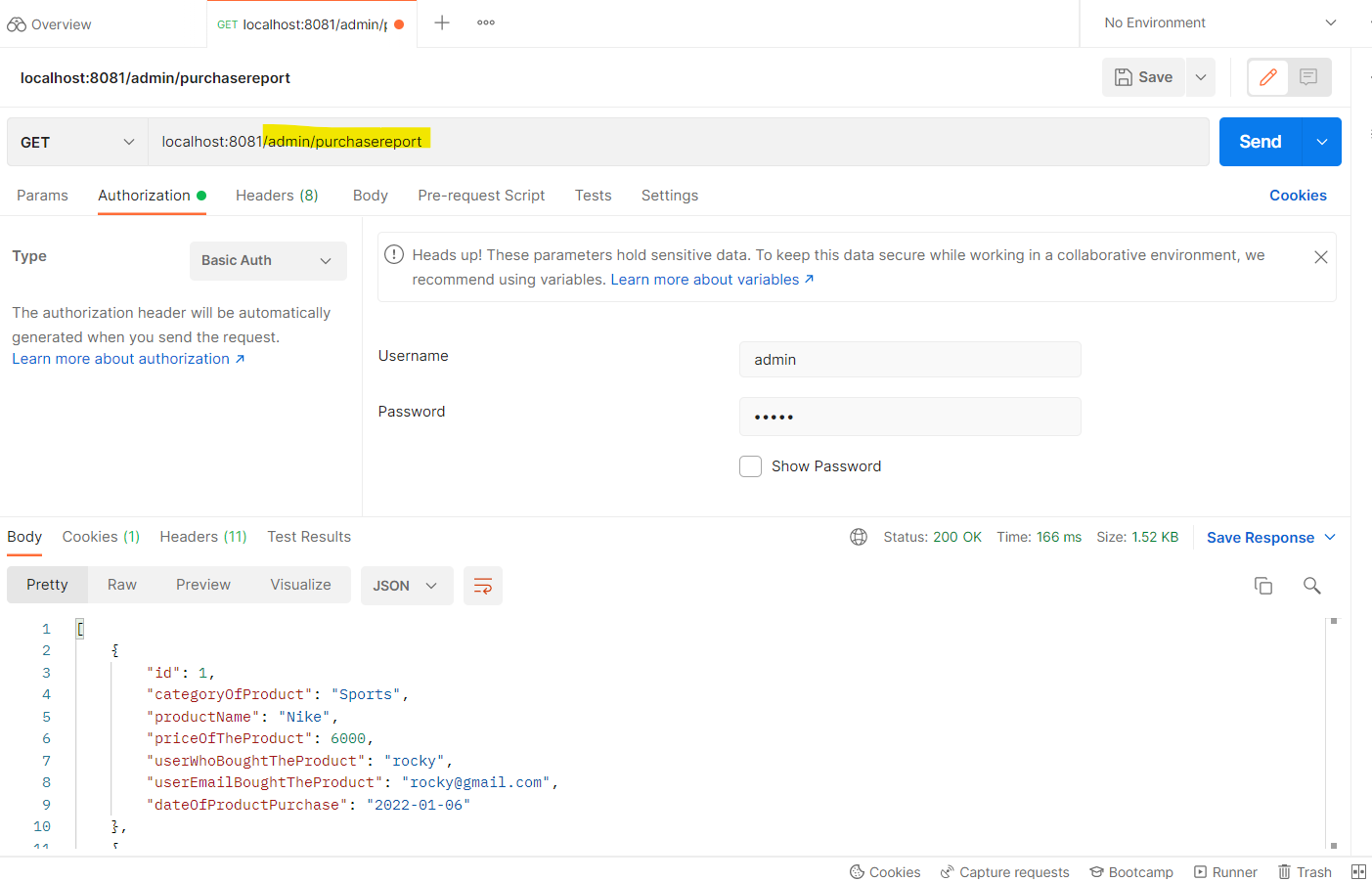

Delete
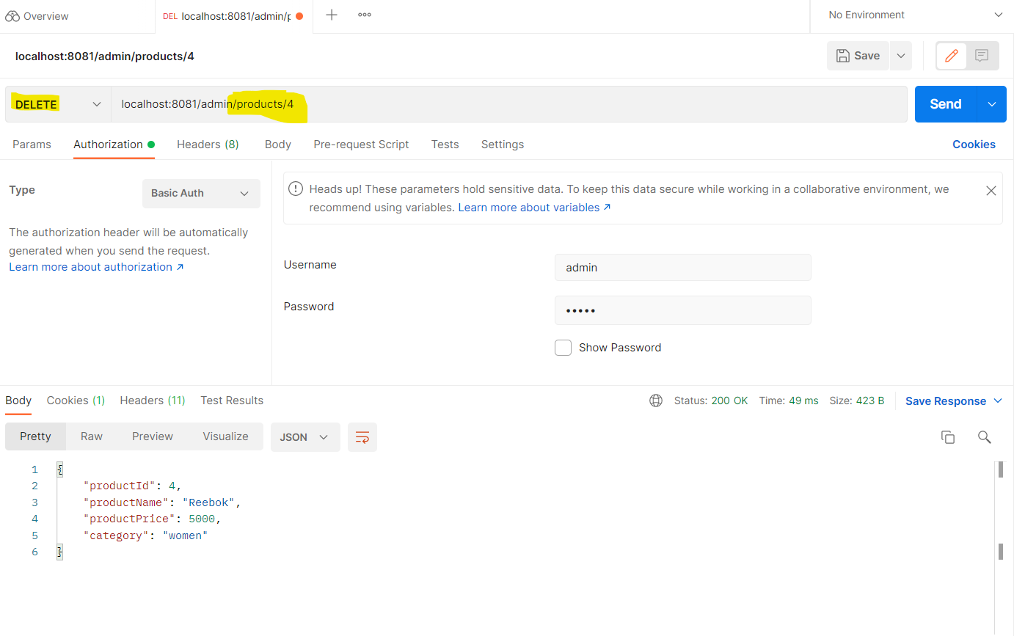
After Deletion
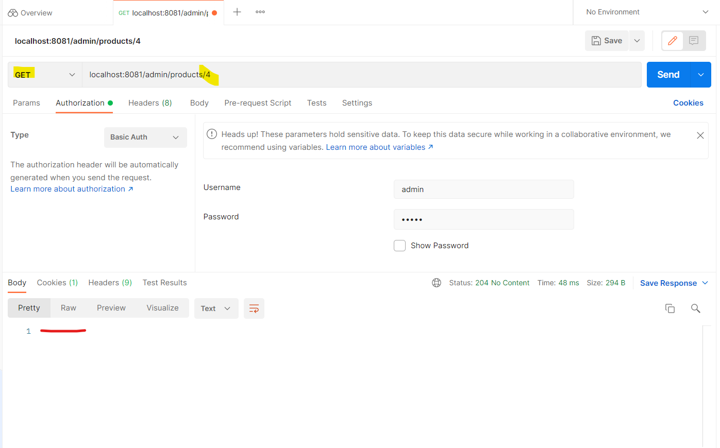

Adding a product
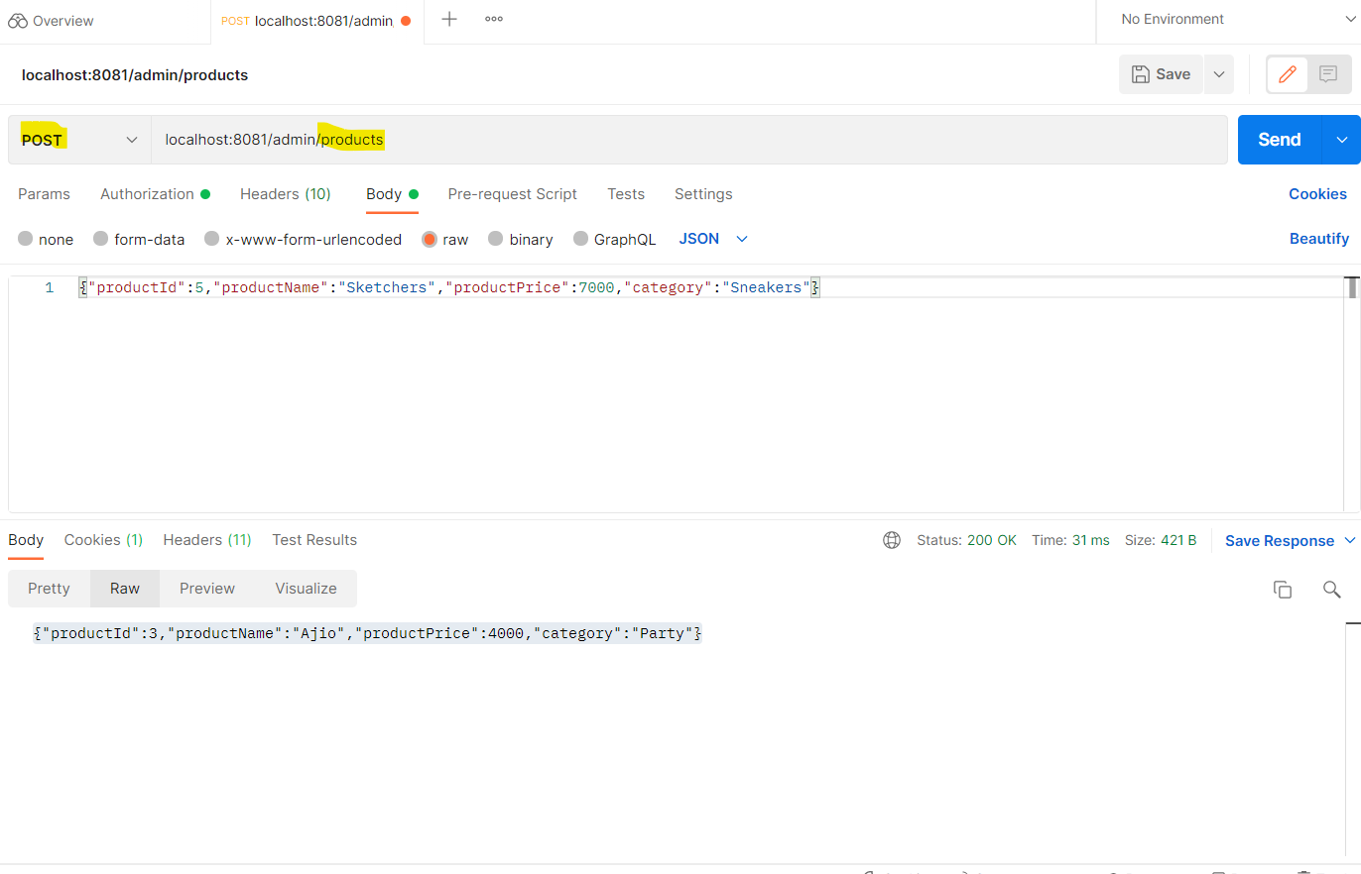
After Insertion
